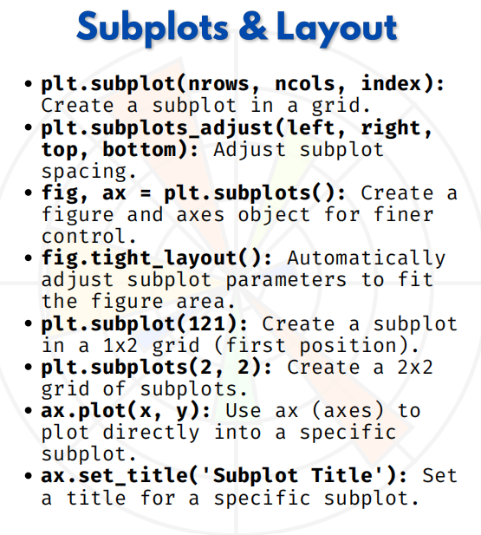

SUBPLOTS & LAYOUT

Subplots & Layout in Matplotlib
Matplotlib allows us to create multiple plots in the same figure using plt.subplot() or plt.subplots().

1. plt.subplot(rows, cols, index)
Create small plots inside one figure.
import matplotlib.pyplot as plt

# 2 rows, 2 columns, 1st plot
plt.subplot(2, 2, 1)
plt.plot([1,2,3], [1,4,9], label="Square")
plt.title("Plot 1")

# 2nd plot
plt.subplot(2, 2, 2)
plt.plot([1,2,3], [1,2,3], label="Line")
plt.title("Plot 2")
plt.tight_layout()
plt.show()

2. fig, ax = plt.subplots() (Better way)
Creates figure and axes objects (OOP style).
fig, ax = plt.subplots()
ax.plot([1,2,3], [1,4,9])
ax.set_title("Simple Subplot")
plt.show()

3. Multiple subplots in grid (2×2)
Easier layout with plt.subplots(rows, cols).
fig, ax = plt.subplots(2, 2)
ax[0,0].plot([1,2,3],[1,4,9])
ax[0,0].set_title("Square")
ax[0,1].plot([1,2,3],[1,2,3])
ax[0,1].set_title("Line")
ax[1,0].bar([1,2,3],[3,2,5])
ax[1,0].set_title("Bar")
ax[1,1].hist([1,1,2,3,3,3,4,5])
ax[1,1].set_title("Histogram")
plt.tight_layout()
plt.show()

4. Sharing axes (sharex, sharey)
Useful for comparing plots.
fig, ax = plt.subplots(2, sharex=True)
ax[0].plot([1,2,3], [1,4,9])
ax[0].set_title("Square")
ax[1].plot([1,2,3], [1,2,3])
ax[1].set_title("Line")
plt.tight_layout()
plt.show()

5. Adjust spacing with plt.tight_layout()
Avoids overlapping of titles and labels.
fig, ax = plt.subplots(2, 2)
for i in range(2):
for j in range(2):
ax[i,j].plot([1,2,3],[1,2,3])
ax[i,j].set_title(f"Plot {i},{j}")
plt.tight_layout()
plt.show()

6. figsize=(width, height)
Control size of figure.
fig, ax = plt.subplots(1, 2, figsize=(10,4))
ax[0].plot([1,2,3],[1,4,9])
ax[0].set_title("Wide")
ax[1].plot([1,2,3],[1,2,3])
ax[1].set_title("Plot 2")
plt.show()

7. Adding super title (fig.suptitle)
Title for the entire figure.
fig, ax = plt.subplots(1, 2)
ax[0].plot([1,2,3],[1,4,9])
ax[1].plot([1,2,3],[1,2,3])
fig.suptitle("Comparison of Graphs", fontsize=14)
plt.show()

8. Complex layout using GridSpec
More flexible than simple rows × cols.
import matplotlib.gridspec as gridspec
fig = plt.figure(figsize=(6,6))
gs = gridspec.GridSpec(2,2)
ax1 = fig.add_subplot(gs[0,:]) # Full top row
ax2 = fig.add_subplot(gs[1,0]) # Bottom left
ax3 = fig.add_subplot(gs[1,1]) # Bottom right
ax1.plot([1,2,3],[1,4,9])
ax2.bar([1,2,3],[3,2,5])
ax3.hist([1,1,2,2,3,3,4,5])
plt.show()

